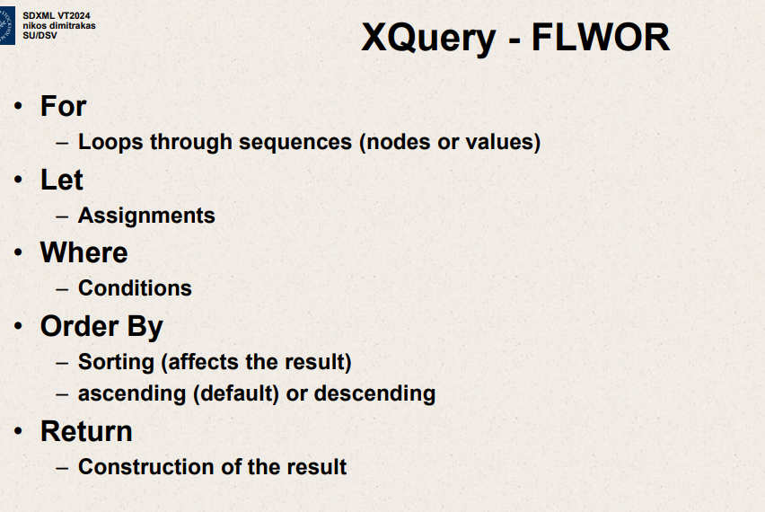

Xquery more familiar when you compare it with SQL.

Basic structure of Xquery

FLWOR expressions

For clause – Loop through nodes.

Let clause – Assign a variable .Very convenient clause. Not really a necessary clause but makes result of query easier to maybe understand.

Where

-conditions.

Order By

Sorting(affect the result)

Ascending(default) or descending

Return

Construction of result

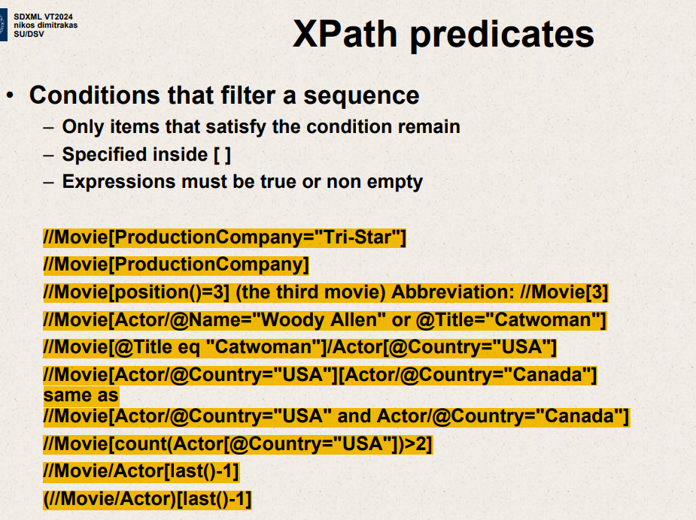

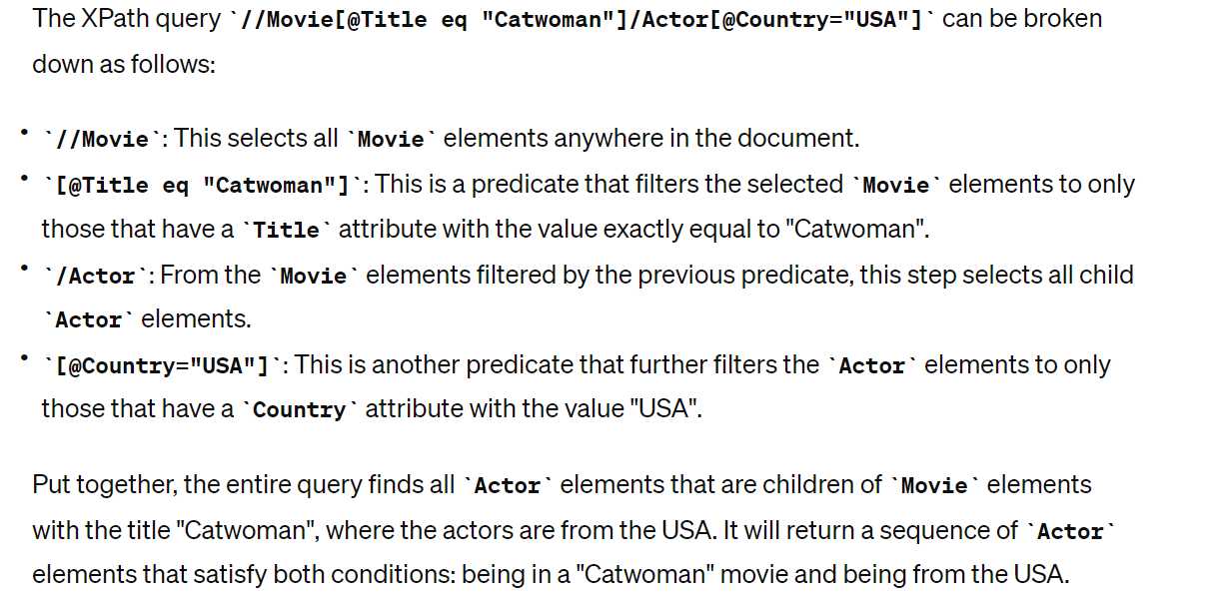

For

Loops through sequences (nodes or values)

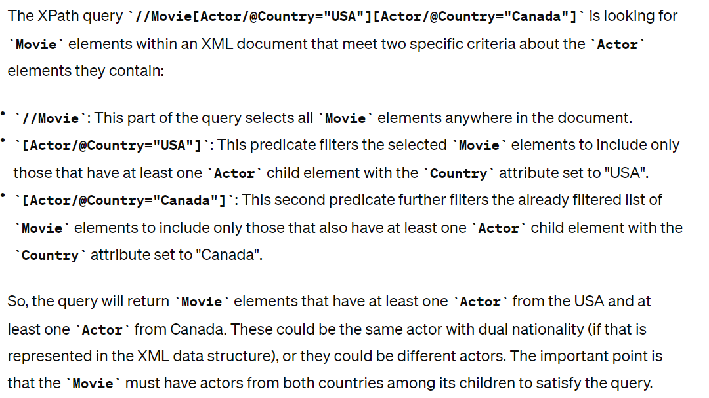

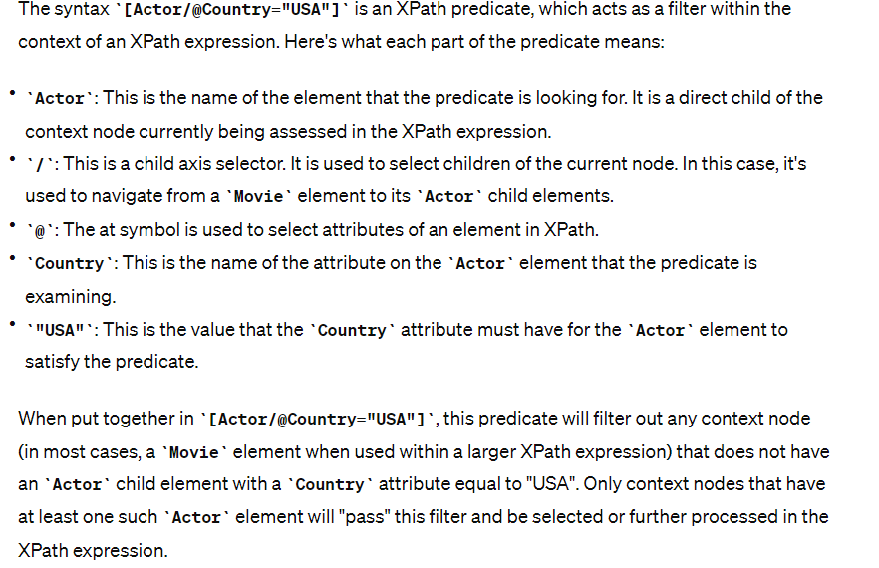



FLWOR statements maybe nested.

No clause is compulsory

For ,let multiple times in random order.

Xpath expressions may be used in all clauses.

For – Loops through sequences(nodes or values)

Let – Assignments

Where – conditions

Order By – Sorting -affects result (ascending or descending)

FLWOR statements may be nested.

No clause is compulsory

For and let may appear multiple times in random order.

Xpath expressions may be used in all clauses.

Result can be well -formed XML ,but does not have to

Doc() can be used to define a source/context (an XML document)

Function doc() to open a specific file

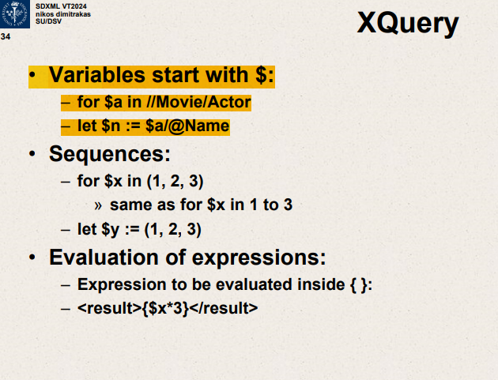

1. One actor element at a time

n = name of actor

Sequences

For $x in (1,2,3)  
same as for $x in 1 to 3

Evaluation of expression:

In {} – expression should be evaluated

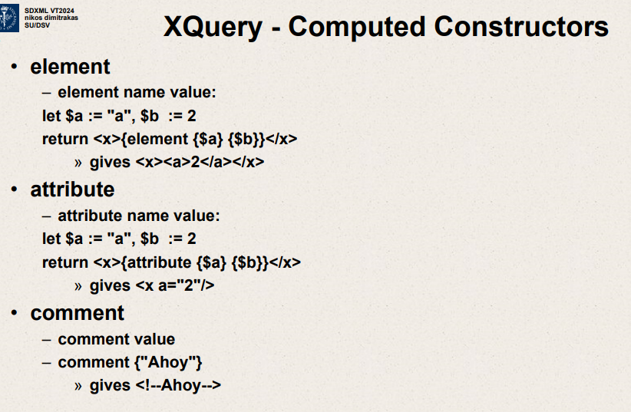

Keywords for creating node types

Element name value

Let $a:=”a” ,$b:=2

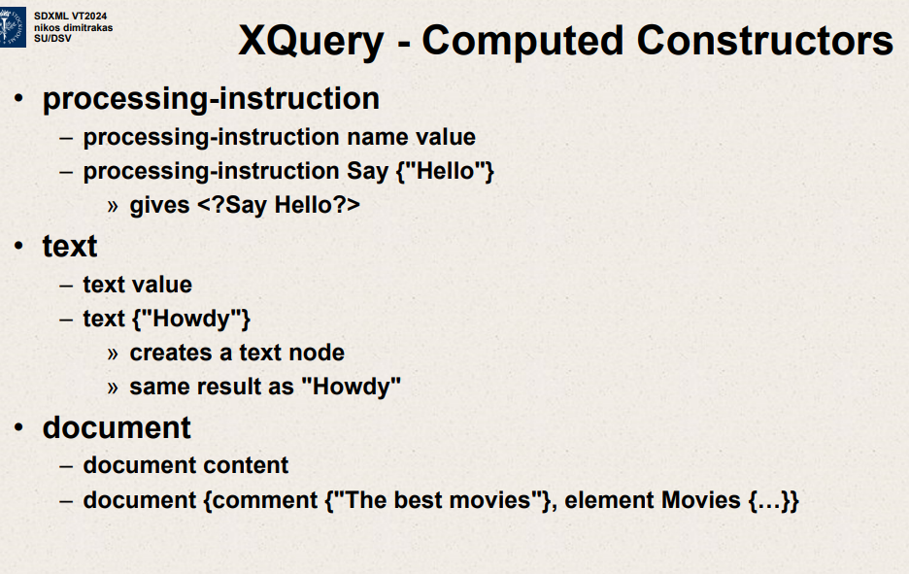

Xquery

Variables start with $ :

For $a in //Movie/Actor

* let $n:=$a/@Name

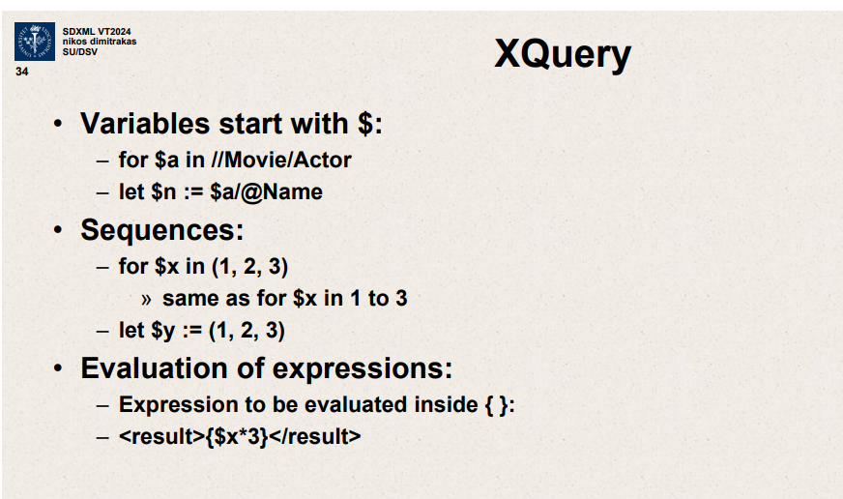



They have processing instruction,name and value.

Say {“Hello”}

<?Say Hello?>

document - the top level root invisible node

document { comment {“The best movies”}}

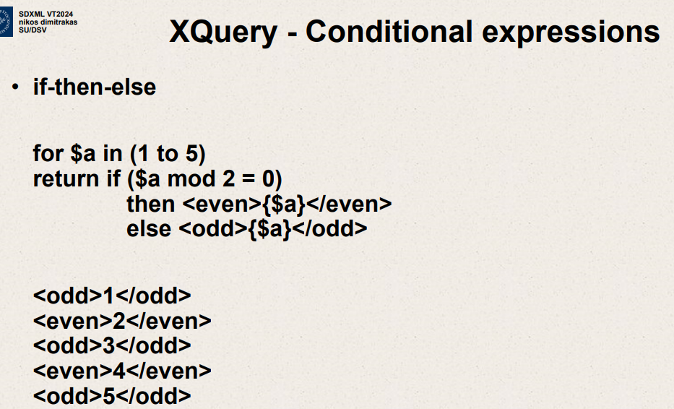

If then else structure to differentiate result based on some conditions

In case of even number then <even>{$a}</even>

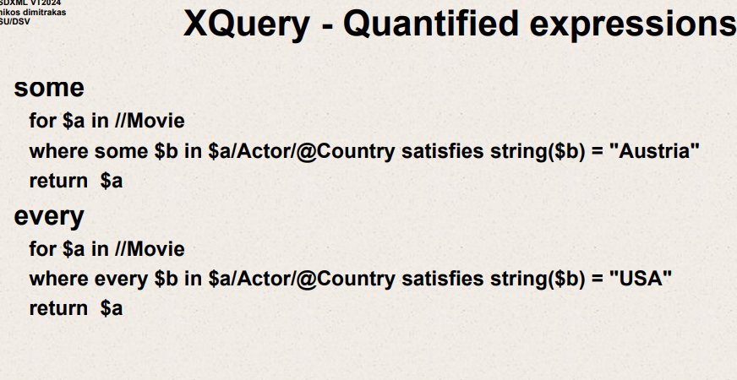

Xquery – quantified expressions

Some

for $a in //Movie

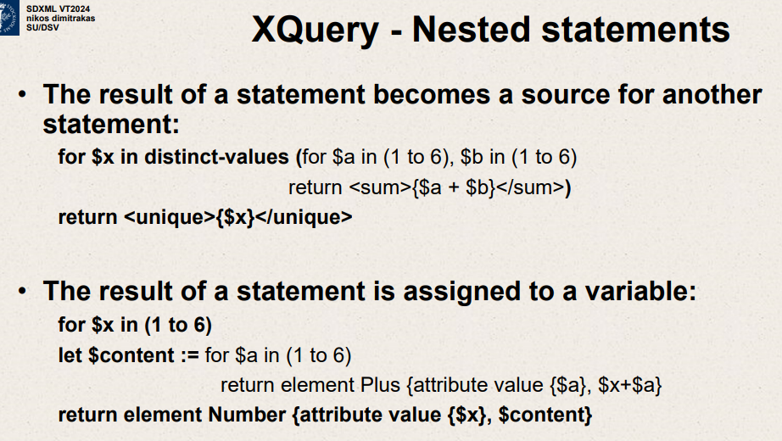

The result of a statement becomes a source for another statement

For $x in (1 to 6)

Let $content := for $a in (1 to 6):

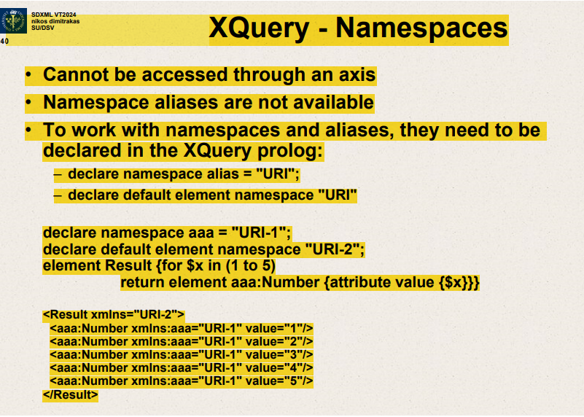

Cannot be accessed through an axis.

Namespace aliases not available

To work with namespaces and aliases, they need to be declared in Xquery prolog.

Declare namespace alias=”URI”

Declare default element namespace “URI”

The uploaded slide discusses namespaces in XQuery, which are a crucial aspect when dealing with XML as they provide a way to avoid name conflicts by qualifying names of elements and attributes with a URI.

Here's a summary of the key points from the slide:

1. **Namespaces in XQuery**:
   * XQuery doesn't provide a way to access or select nodes based purely on their namespace via an axis as you might with other node attributes.
   * Unlike some other XML-related languages, XQuery does not allow namespace aliases to be used directly within path expressions or predicates.
2. **Declaring Namespaces**:
   * Namespaces are declared in the prolog of an XQuery script. The prolog is the section before the main body of the query where setup instructions are given.
   * The slide provides syntax for declaring a namespace with an alias (**declare namespace alias = "URI";**) and for declaring a default element namespace (**declare default element namespace "URI";**).
3. **Example Usage**:
   * The provided code snippet shows the declaration of a namespace with the prefix **aaa** mapped to **"URI-1"** and the declaration of a default element namespace **"URI-2"**.
   * Then it demonstrates the construction of an XML document with the **<Result>** element being in the default namespace **"URI-2"** and child **<Number>** elements in the namespace **"URI-1"** as indicated by the **aaa** prefix.
   * Each **<Number>** element is given an attribute **value** containing the numbers from 1 to 5.
4. **Resulting XML**:
   * The output XML shows the **<Result>** element with the default namespace. Because **Result** is not prefixed, it assumes the default namespace **xmlns="URI-2"**.
   * The child **<Number>** elements have the namespace prefix **aaa** which is associated with **"URI-1"**, hence each **<Number>** element is in a different namespace from **<Result>** and is fully qualified with **xmlns:aaa="URI-1"**.
   * The attribute **value** does not have a namespace prefix, so it belongs to no namespace.
5. **Interpreting the XML Output**:
   * The **<Result>** element has the default namespace URI **"URI-2"**.
   * Each **<aaa:Number>** element is in the namespace **"URI-1"** and contains an attribute **value** with its corresponding value from the loop.

This slide serves to explain how namespaces function within the context of XQuery and the significance of declaring them correctly in the prolog for proper XML document construction and querying.

Xquery prolog

Can declare functions, global variables, namespaces , collation and sorting.

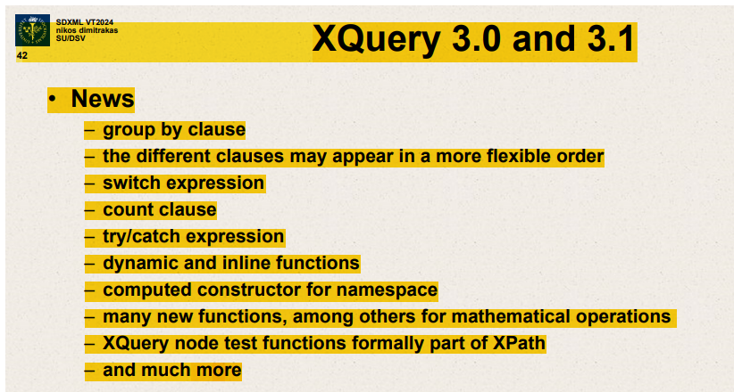

Group by clause

Different clauses may appear in more flexible order.

Switch expression

Count clause – counts all the iterations

Computed constructor for namespace

Extended library of functions – dynamic ,inline functions, computed constructor for namespace , many new functions for math operations

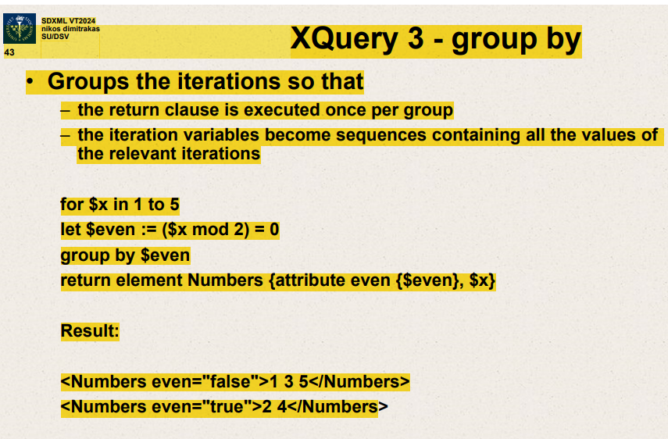

For – makes iterations

Groups the iterations so return clause executed once per group

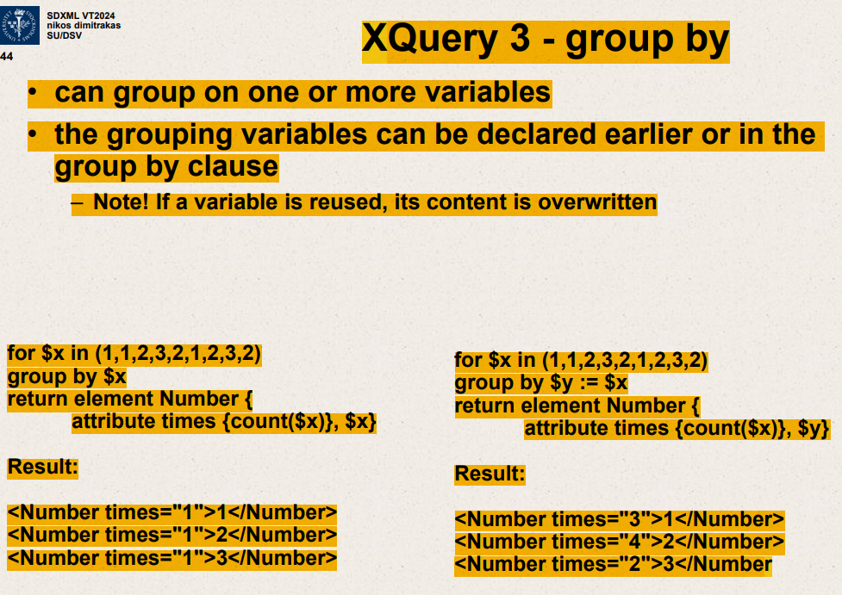

Can group on one or more variables.

Grouping variables can be declared earlier or in group by clause.

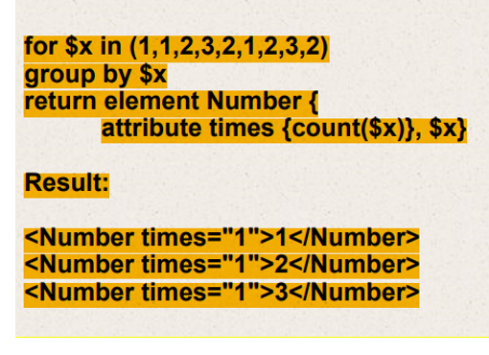

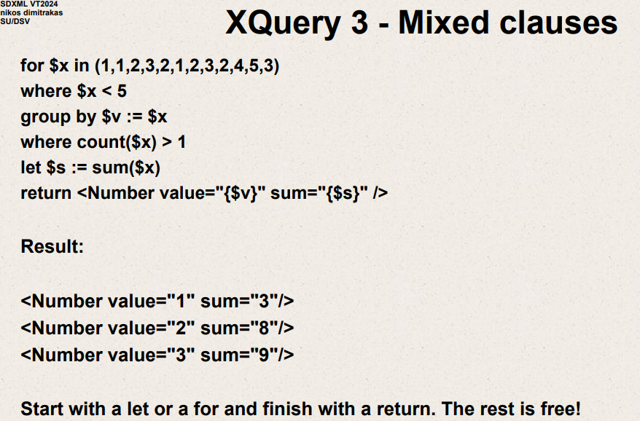

Dynamic functions

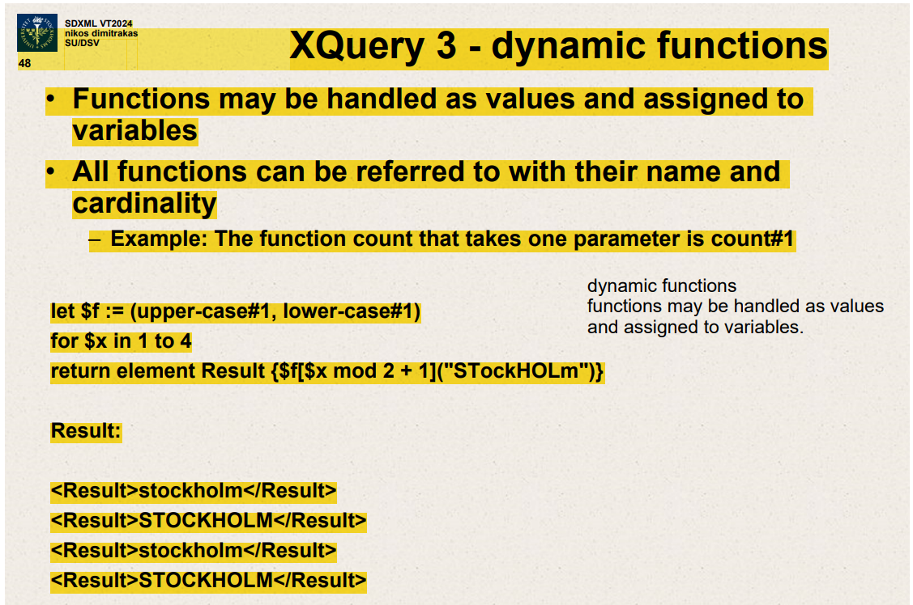

Functions may be handled as values and assigned to variables

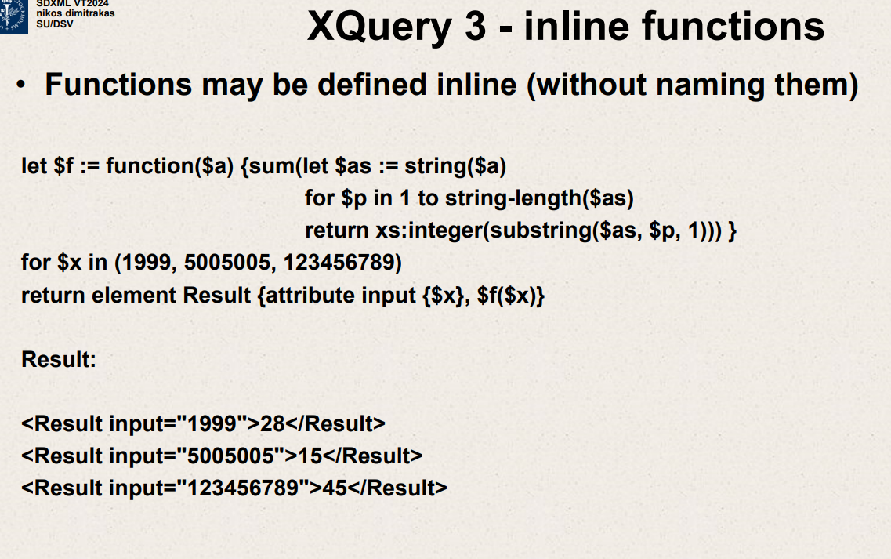

Functions can be defined inline(without naming them)

Let $f :=function($a)

In the image, there's an XQuery script demonstrating the use of inline functions. This script defines an inline function **$f** that calculates the sum of the digits of a given number **$a**. The script then iterates over a set of numbers, applies the function to each number, and returns the result as an XML element with the original input number as an attribute.

Here's a breakdown of the code and what it does:

1. The inline function **$f** takes a number **$a**, converts it to a string **$as**.
2. It then iterates over each character (digit) in the string representation of the number.
3. Each character is converted back into an integer.
4. The function then sums all these integers (the digits of the original number).
5. For each number in the given sequence (1999, 5005005, 123456789), the script applies the function **$f** and creates an XML **Result** element.
6. The **Result** element has two attributes: **input**, which is the original number, and the text content, which is the sum of the digits as calculated by **$f**.

The output shown in the image is as follows:

* For the input **1999**, the sum of the digits is **1+9+9+9** which equals **28**.
* For **5005005**, it is **5+0+0+5+0+0+5** which equals **15**.
* For **123456789**, the sum is **1+2+3+4+5+6+7+8+9** which equals **45**.

So the result is:

* **<Result input="1999">28</Result>**
* **<Result input="5005005">15</Result>**
* **<Result input="123456789">45</Result>**

This is a clear illustration of how an inline function in XQuery can be used to perform a calculation across multiple items in a sequence and embed the results within XML elements. If you're looking to understand more about this example or inline functions in general, feel free to ask!

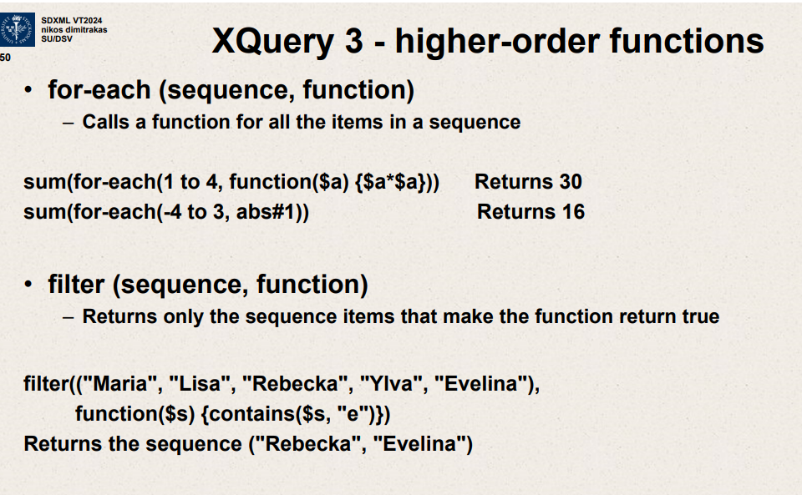

for each ( sequence,function)

-calls function for all items in a sequence.

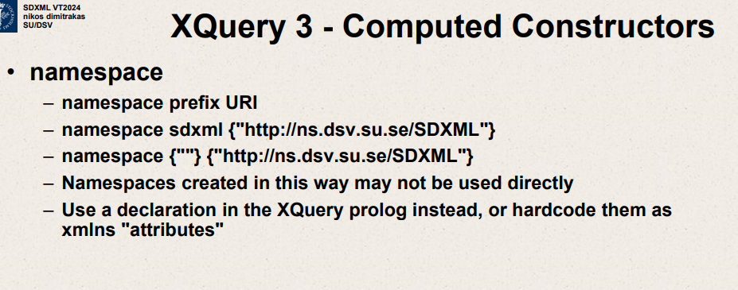

This new image is another slide from what appears to be a presentation on XQuery 3, specifically about Computed Constructors related to XML namespaces.

Here's a summary of the content:

* It discusses how to define a namespace within XQuery. A namespace is used to avoid naming conflicts by qualifying names with a URI.
* A namespace declaration is shown with a prefix (**sdxml**) and a URI (**http://ns.dsv.su.se/SDXML**).
* An example of a namespace declaration without a prefix is also shown, where **{""}** is used to indicate a default namespace.
* It notes that namespaces created in this manner may not be used directly.
* The slide advises to use a namespace declaration within the XQuery prolog or to hardcode them as **xmlns** attributes, which are declarations within XML documents to define namespaces.

Namespaces are an important part of XML and XQuery because they enable the use of the same element or attribute names within different contexts or XML vocabularies without conflict. The slide is emphasizing best practices in defining and using namespaces in your XQuery code. If you're writing XQuery and working with XML documents that may have overlapping or conflicting element names, using namespaces is crucial for clarity and to prevent errors.

Namespaces in XML and XQuery are used to differentiate elements and attributes that may have the same name but different meanings. They are essential when combining XML documents from different XML vocabularies to prevent name collisions. Here's an outline of how namespaces are used in both XML and XQuery

**In XML:**

1. **Defining Namespaces:**
   * Namespaces are defined by the **xmlns** attribute in the start-tag of an element.
   * The **xmlns** attribute's value is a URI that uniquely identifies the namespace.
   * A prefix can be bound to the namespace URI, and this prefix is then used to qualify the names of elements or attributes.

**Example**

<invoice xmlns="http://example.com/invoice">

<payment xmlns="http://example.com/payment">

<!-- Elements inside here are part of the payment namespace --> </payment>

<!-- Elements here are part of the invoice namespace --> </invoice>

1. **Default Namespace:**
   * If a prefix is not provided, the namespace applies to all enclosed elements.
   * Default namespaces do not apply to attributes.
2. **Prefixed Namespace:**
   * Assigning a prefix allows for the use of multiple namespaces in the same document.
   * Attributes always need a prefix to be in a namespace.

**In XQuery:**

1. **Declaring Namespaces:**
   * In XQuery, namespaces are declared in the prolog of the query with the **declare namespace** keyword.
   * The namespace can then be used throughout the query to qualify element and function names.
2. **Example:**

xqueryCopy code

declare namespace inv = "http://example.com/invoice"; declare namespace pay = "http://example.com/payment"; <inv:invoice> <pay:payment> <!-- Elements can be qualified using the namespace prefixes --> </pay:payment> </inv:invoice>

1. **Using Default Namespaces:**
   * XQuery also allows for a default element and function namespace to be declared.
   * This means that unqualified names are treated as being in the default namespace.
2. **Computed Constructors:**
   * Namespaces can be dynamically assigned to elements using computed constructors.
   * Example using a computed constructor:

xqueryCopy code

element { QName("http://example.com/payment", "details") } { ... }

**Importance of Namespaces:**

* **Uniqueness:** They ensure that elements from different sources can be uniquely identified.
* **Integration:** Namespaces enable the integration of XML documents from various domains.
* **Extensibility:** They allow XML vocabularies to be extended without fear of name clashes.
* **Clarity:** In XQuery, namespaces make it clear which functions or elements come from which modules or vocabularies.

Using namespaces properly in XQuery and XML is vital for clear, maintainable, and error-free code, especially in environments where multiple vocabularies and data sources are involved.

In the context of XML and XQuery, namespaces are a method of avoiding conflicts by differentiating elements and attributes within XML documents that may have the same name but different contexts or meanings. There are two types of namespace declarations you might encounter: default namespaces and prefixed namespaces.

**Default Namespace**

A default namespace is a namespace that is declared without a prefix and applies to all unqualified element names within its scope. In XML, this is done with the **xmlns** attribute without a colon.

**XML Example of a Default Namespace:**

xmlCopy code

<book xmlns="http://www.example.org/library"> <title>A Great Book</title> <author>John Doe</author> </book>

In this example, the elements **book**, **title**, and **author** are all in the **http://www.example.org/library** namespace. Since there is no prefix, they are considered to be in the default namespace. Note that default namespaces do not apply to attributes, only to elements.

**Prefixed Namespace**

A prefixed namespace is one where a namespace prefix is bound to a namespace URI. The prefix is then used to qualify names of elements and attributes to indicate that they are in that specific namespace.

**XML Example of a Prefixed Namespace:**

<lib:book xmlns:lib="http://www.example.org/library"> <lib:title>A Great Book</lib:title> <lib:author>John Doe</lib:author> </lib:book>

In this XML, the prefix **lib** is associated with the URI **http://www.example.org/library**. The elements **book**, **title**, and **author** are all qualified with this prefix, indicating that they belong to the **http://www.example.org/library** namespace. Prefixed namespaces can be used for attributes as well.

**In XQuery**

XQuery also supports both default and prefixed namespaces. Here's how they are defined in the prolog of an XQuery:

**XQuery Example:**

xqueryCopy code

declare default element namespace "http://www.example.org/library"; declare namespace lib = "http://www.example.org/library"; <book> <!-- This is in the default namespace --> <title>A Great Book</title> <lib:book> <!-- This is in the prefixed namespace --> <lib:title>Another Great Book</lib:title> </lib:book> </book>

In the example above, the **declare default element namespace** line sets the default namespace for elements. This means that any unqualified element names in the query are considered to be in the **http://www.example.org/library** namespace. The **declare namespace** line establishes a prefix that can be used to explicitly place elements in the namespace identified by the URI.

Using namespaces in XML and XQuery is essential for preventing name conflicts, especially when combining XML documents from different sources or when extending existing XML vocabularies.

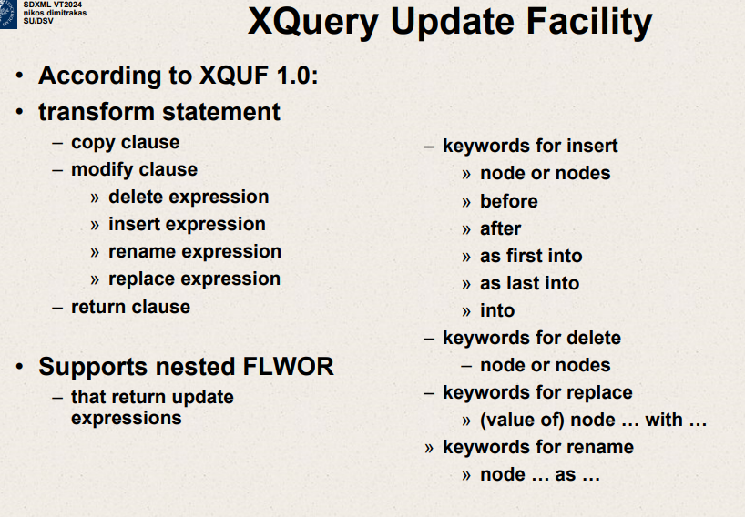Top of Form

The slide you've uploaded is discussing the XQuery Update Facility (XQUF), which extends the XML Query language (XQuery) with features that allow the modification of XML data.

The slide outlines the various components and keywords used in XQUF to perform update operations on XML data. Here’s a brief explanation of the terms and their purpose:

**XQuery Update Facility Components**

1. **Transform Statement**: It is the core of the update facility that enables modifications. It consists of:
   * **Copy Clause**: Creates a deep copy of the data to be modified, leaving the original intact.
   * **Modify Clause**: Specifies the actual changes to be applied to the copy. It includes:
     + **Delete Expression**: Removes nodes.
     + **Insert Expression**: Adds nodes.
     + **Rename Expression**: Changes the name of nodes.
     + **Replace Expression**: Substitutes nodes.
   * **Return Clause**: Outputs the modified copy after all changes have been applied.
2. **Supports Nested FLWOR**: XQUF allows nested FLWOR expressions (For, Let, Where, Order by, Return) that include update expressions. FLWOR expressions are a powerful feature of XQuery that enable complex querying and data manipulation.

**Keywords for Update Operations**

* **For Insert**:
  + **node or nodes**: The item(s) being inserted.
  + **before**: The location where the nodes will be inserted before.
  + **after**: The location where the nodes will be inserted after.
  + **as first into**: Inserts nodes at the beginning of the target location.
  + **as last into**: Inserts nodes at the end of the target location.
  + **into**: The container where the nodes will be inserted.
* **For Delete**:
  + **node or nodes**: The item(s) being removed.
* **For Replace**:
  + **(value of) node ... with ...**: The replacement operation, which can change either the entire node or just its value.
* **For Rename**:
  + **node ... as ...**: The operation to rename a node.

The XQuery Update Facility provides a way to perform changes on an XML data structure directly within an XQuery, which is extremely useful for applications that need to not only query but also update XML data stores. It should be noted that not all XQuery implementations support XQUF, so one should ensure compatibility before relying on these features.

Top of Form

